WHO Consultation
The Strategic Use of Antiretrovirals
for Treatment and Prevention of HIV
Geneva 14-16 November 2011

EXECUTIVE SUMMARY

1. Introduction
The use of antiretrovirals (ARVs) for treatment and for prevention of HIV is a dynamic and rapidly evolving field. Since the release of the 2010 World Health Organization (WHO) guidelines for antiretroviral therapy (ART) for treating adults and children [1, 2] and the prevention-of-mother to child transmission (PMTCT) [3], important new evidence has emerged demonstrating the benefit of earlier initiation of ART for the HIV-positive individual to prevent onward transmission to their HIV-negative partner [4] and oral as well as topical antiretroviral pre-exposure prophylaxis (PrEP) for the HIV-negative individual [5,6] to prevent HIV acquisition. At the same time, there is a renewed global commitment to making major progress in reducing morbidity, mortality and new infections [7-9].

Against this background, WHO convened a 3-day expert consultation in November 2011 to help inform the process of translating the latest evidence into new guidance. This consultation brought together global scientific and policy leadership, senior researchers, national AIDS programme managers, ethicists, human rights experts, and civil society representatives (see attached list of participants) to inform future WHO guideline development on the use of ARVs to treat and prevent HIV, and identify key areas where additional research, modelling and demonstration projects are needed. The expected output of the meeting was a roadmap to advise WHO on the possible scope, content, timing and format of updated and new guidance in the short term and up to 2015.

2. WHO future ARV related guidance architecture (Figure)
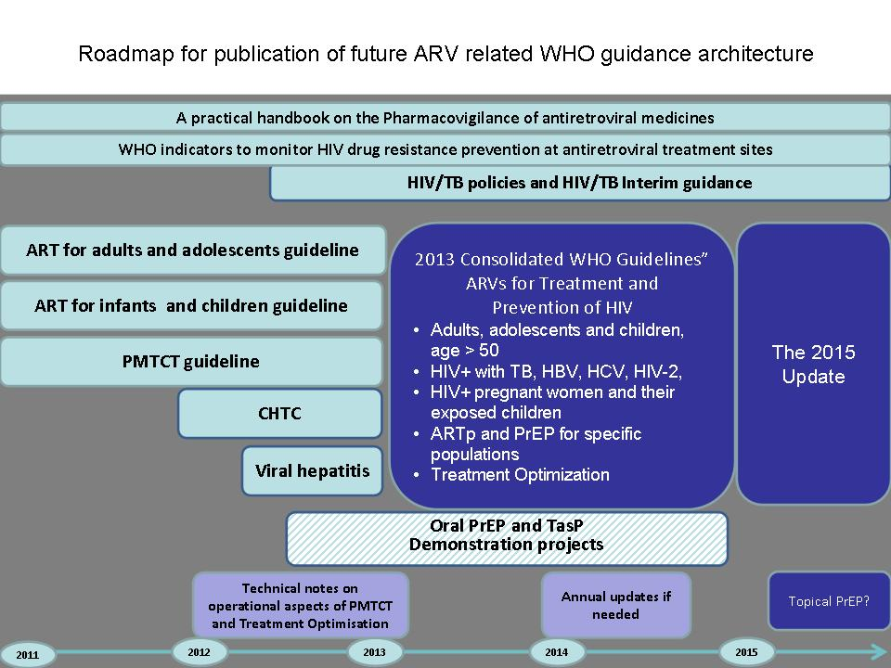
WHO presented two important changes that are foreseen for the next set of guidelines:
1. Expansion of scope of guidelines and
2. A shift towards consolidation of guidance for different populations.

- Expansion of scope of guidelines
WHO guidelines to date have emphasized recommendations more focused on the prevention or clinical management of HIV. The aim is to structure the guidance to better reflect country realities and to facilitate the development of comprehensive national HIV policies and guidelines. Therefore plans for the consolidated 2013 guidelines will include both programmatic and operational dimensions. Programmatic guidance will provide a framework within which policies, interventions and resources are prioritized and delivered in order to reach national goals and objectives in different epidemiological settings. Operational guidelines will inform service delivery and systems requirements at different levels of services. This move towards an expanded scope of guidelines is in line with the ongoing work in the context of WHO/UNAIDS Treatment 2.0 Framework for Action [10]. It recognizes that increasing access to treatment and reaping the benefits of prevention interventions are confronted by the considerable operational challenges of testing more people earlier, enrolling and retaining them in care and ART earlier, increasing access to ART at decentralized levels, and maintaining high levels of treatment adherence.

- A shift towards consolidation of guidance for different populations
The availability of multiple individual guidelines for different target groups (adults, children, pregnant women, co-infections) and interventions (treatment and prevention) can lead to confusion, complexity as well as fragmentation of services. Practically, this new approach will require a review and revision of already existing, currently separate, guideline documents (e.g.; ART for adults, ART for children, PMTCT), and the development of recommendations in areas where these currently do not yet exist (e.g. Treatment as Prevention and PrEP).

The first set of these comprehensive and consolidated guidelines will be released in 2013. It is anticipated that a biennial revision would be carried out from there onwards (2015, 2017, etc.) to ensure incorporation of new science and implementation experiences as needed. In the interim, concise policy updates will be provided as needed. Rapid advice (a WHO review process to facilitate swift development of new recommendations in cutting-edge areas) will be issued as required.

- Evidence review and major areas addressed

Participants reviewed recently published trial findings and the expected timing of reports from on-going and planned studies in which ARVs are used for HIV treatment, prevention and/or PMTCT. Scientific roadmaps were presented to allow for consideration of the potential impact of on-going trials to inform strategies, policies and guidelines for the use of ARVs for HIV treatment and prevention.

Working groups were convened at the meeting to provide recommendations on five major areas: ART for the treatment of adults and children living with HIV, the impact of ART on other health conditions, ART for HIV prevention, PMTCT and PrEP. Aspects of equity, ethics and human rights were reviewed in each working group.

  - ART for adults and children
Discussions focused on the questions of when to start ART, and what regimens to use. For the general adult population, it was considered that the recommendation for when to start for individual health (≤350 cells/mm³) would likely remain unchanged until the results of on-going randomized trials are available [11, 12]. For children, discussions highlighted the need to simplify guidance on when to start for children particularly those aged between 2 and 5 years where the initiation criteria are different than for older children and adolescents. The benefit of early ART initiation for children older than 1 year is not clearly established [13] and observational data will be important to help inform decisions regarding immediate versus deferred treatment for this age group. Regarding which regimen to be used at initiation of ART, there was a recognized need to harmonize regimens across populations, if at all possible. One set of preferred options should be identified for first-line and second-line regimens for adults, older children and pregnant women. Specific guidelines for younger children (below 2 years) would be maintained, given that ART for infants should be initiated immediately [2] and that tenofovir disoproxil fumarate (TDF), which is a main component of primary first-line regimen for adult treatment, is currently not yet approved for use in children [13].

  - Impact of ART on prevention and outcomes of other health conditions
This working group mainly focused on the potential for earlier use of ART (>350 CD4 cells/mm³) to prevent TB. The HPTN 052 trial, for example, found a reduction in extra-pulmonary TB in the patients who initiated ART early, at CD4 350-500 cells/mm³ (3 cases) compared to those for whom treatment was initiated at CD4 ≤250 cells/mm³ (17 cases) [14]. A systematic review is underway to address this question, and if benefit is established rapid advice should be considered. In the meantime, current WHO advice on early initiation of ART in TB patients, TB preventive therapy for household and close contacts should be supported [15]. Regarding other co-infections, current guidelines recommend early initiation of ART in individuals co-infected with hepatitis B virus with evidence of chronic active hepatic disease. There is insufficient evidence to consider a similar recommendation for individuals co-infected with hepatitis C virus, and this needs further study. Evidence considering earlier ART initiation for other co-morbidities and conditions, including malaria, cancers, cardiovascular disease, diabetes, liver disease, and neuropathy should also be reviewed. Evidence related to the benefits of earlier initiation of ART for people >50 years of age should be considered.

  - ART for prevention
The concept of “treatment as prevention” – that ART lowers viral load and reduces the probability of transmission – has been posed for over a decade [16, 17]. This concept was confirmed by the results of the HPTN 052 trial that demonstrated a 96% reduction in transmission among serodiscordant couples who initiated treatment (in the HIV-infected partner) early compared to those for whom treatment was deferred [4]. Given that the majority of trial participants (97%) were heterosexual couples and 95% were married [18], uncertainty remains regarding the extent to which the HPTN 052 results could be translated to other populations such as casual partnerships, sex workers, and other modes of transmission such as among men who have sex with men (MSM) and people who inject drugs. However, it was acknowledged that the magnitude of the effect may be different from that observed in serodiscordant heterosexual couples, [18]. Efforts should be directed at cohort studies and implementation research to help inform whether earlier HIV testing and treatment are acceptable, feasible, and affordable, and to what extent sufficient levels of adherence and viral suppression could be sustained outside of clinical trial settings in different populations and for different modes of transmission. Participants encouraged WHO to take a clear position regarding treatment as prevention.

  - PMTCT
Current WHO guidelines released in 2010 emphasize the importance of initiation of life-long combination ART for HIV-infected pregnant women with CD4 counts <350 cells/mm³ or WHO stage 3 or 4 clinical disease (approximately 40% of HIV-infected pregnant women). For women who do not yet need ART for their own health, the guidelines offers a choice of two prophylaxis options for PMTCT is recommended: the time-limited use of antepartum zidovudine (AZT) plus intrapartum single-dose nevirapine (sdNVP) and one week of AZT/3TC to the mother and daily infant NVP through 12 months of breastfeeding (Option A), or use of a maternal triple drug regimen during pregnancy and through 12 months of breastfeeding (Option B) [3]. Option A has been considered as a less costly option, and a number of countries have adopted this choice. It was recommended that WHO should indicate and weigh preferences as much as possible where a range of options are provided. It was noted by workgroup members that Option B provides the opportunity to directly integrate PMTCT with first-line adult treatment recommendations and Treatment 2.0. A number of countries are now moving towards the provision of ART to pregnant women for life, irrespective of clinical and immunological staging (so-called Option B+), recognizing the prevention benefit of earlier treatment. Early experience from those settings could address whether practical issues in settings with limited resources and high fertility rates (e.g. difficulty in assessing CD4 to determine treatment eligibility and the advantage of continuously providing a single regimen without interrupting or changing ARVs) as well as the challenge of choice of regimen in pregnant women with high CD4+ cell count might be overcome [19] and will be an important contribution to future WHO guideline development.

PMTCT was identified as an area where interim operational and programme guidance is urgently needed in order to achieve PMTCT country targets. It was recognized that elimination of MTCT requires more than just ARVs, and that important implementation barriers need to be overcome, including defining strategies to increase community demand for services, and reinforce linkage to and retention in care, in order to make substantial progress towards achieving the WHO target of reducing MTCT by 90% by 2015 [5].

  - PrEP
A number of trials have evaluated the effect of oral or topical ARVs as pre-exposure prophylaxis (giving ARVs to HIV-negative individuals to prevent acquisition of HIV), and while the effect size varies, it was considered that there is sufficient evidence to develop guidance for demonstration projects for the use of the oral TDF/emtricitabine (FTC) combination in certain populations including men who have sex with men and serodiscordant couples [5,6]. The implementation of PrEP in the field poses a number of operational research questions such as the feasibility of administering ARVs to HIV-negative individuals on an ongoing manner. Supporting adherence to ARVs in healthy HIV-negative individuals, supporting ongoing risk reduction, monitoring adverse events and the cost as well as effectiveness of PrEP in addition to current prevention technologies are among the pressing questions that need to be tackled through demonstration projects.

  - HIV testing and re-testing
The role of expansion of earlier access to HIV testing was emphasized. New HIV testing approaches, implementation of quality assured testing and retesting and linkages to prevention, care and treatment are required. The particular role of couples testing and counselling was discussed. Training needs of providers on simple methods for excluding acute HIV infection before starting PrEP and counselling about new prevention technologies such as treatment as prevention, and PrEP were raised.
Conclusions and recommendations
The following areas were considered to be priorities for the development of new WHO guidance:
- The meeting participants endorsed the roadmap and proposed guideline architecture (Figure) for the development of consolidated WHO guidelines by 2013, addressing clinical, operational and programmatic dimensions and different populations for the strategic use of ARVs for both HIV treatment and prevention.

- Given that recent new data have emerged warranting recommendations from WHO in the short term it, the meeting participants recommended that WHO release the following interim guidance in 2012.

  - Release a technical update in early 2012 on Treatment as Prevention and its potential implications for country programmes. In addition, it was recommended to release a recommendation (“rapid advice”) for implementation research to help gather evidence on the acceptability, feasibility and effectiveness beyond serodiscordant couples such as among MSM and sex workers, and possibly other groups.
  - Finalize guidelines on couples testing and counselling and ART for prevention of HIV in serodiscordant couples in early 2012.
  - Finalize rapid advice on PrEP for demonstration projects, with a focus on MSM and serodiscordant couples, to help gather evidence on the acceptability, feasibility and operational aspects of PrEP delivery services in demonstration projects.
  - Release a technical update on PMTCT that reviews programme experience and indicates preferences within the range of PMTCT options; and
  - Provide operational guidance on HIV testing approaches, in particular on HIV testing strategies and the use of rapid tests.

Next steps
- WHO will start the process to implement the proposed guideline roadmap and architecture for 2013 (Figure). To that regard WHO will establish a number of Guidelines Development Working Groups to start the process of reviewing, updating and consolidating existing WHO guidelines/recommendations.
- WHO will finalize and release the interim guidance as listed above.
- WHO will convene a consultation on the Strategic Use of Antiretrovirals in May 2012 to consider operational and programmatic issues related to the development of consolidated ARV guidelines, including issues related to: modelling of costs and impact; prioritization of policies, interventions and resources, ethics and human rights.
- In preparation for the development and release of the full set of consolidated guidelines, additional technical consultations will take place, including in the following areas: the use of diagnostics, the role of CD4+ cell count and viral load measurements in treatment initiation and monitoring, and information on various service delivery models.

These conclusions do not necessarily represent the decisions or policies of the World Health Organization. For further information please contact Dr Gottfried Hirnschall (hirnschallg@who.int), Dr Ying-Ru Lo (loy@who.int) and Dr Andrew Ball (balla@who.int).

References
- Antiretroviral therapy for HIV infection in adolescents and adults. Recommendations for a public health approach. World Health Organization, Geneva, Switzerland, 2010.
- Antiretroviral therapy for HIV infection in infants and children Recommendations for a public health approach. World Health Organization, Geneva, Switzerland, 2010.
- Antiretroviral drugs for treating pregnant women and preventing HIV infection in infants. Recommendations for a public health approach 2010 version. World Health Organization, Geneva, Switzerland, 2010.
- Cohen MS, Chen YQ, McCauley M, et al. Prevention of HIV-1 infection with early antiretroviral therapy. N Engl J Med 2011; 365:493-505.
- Grant RM, Lama JR, Anderson PL et al. Preexposure chemoprophylaxis for HIV prevention in men who have sex with men. N Engl J Med 2010; 363:2587-2599.
- Baetan J et al. Initial results of the Partners PrEP trial of oral pre-exposure prophylaxis in serodiscordant couples. Late breaker, 6th IAS Conference on HIV Pathogenesis, Treatment and Prevention. Rome, Italy, 17-20, 2011, Abstract number MOAX0106.
- World Health Organization. Global Health Sector Strategy on HIV/AIDS 2011-2015. Geneva, Switzerland, 2011.
- UNAIDS. Getting to Zero: 2011-2015 Strategy. Geneva, Switzerland, 2010.
- United Nations General Assembly. Political Declaration on HIV/AIDS: intensifying our efforts to eliminate HIV/AIDS. Resolution adopted by the General Assembly on 10 June 2011. A/RES/65/277.
- The Treatment 2.0 Framework for Action: Catalysing the next phase of treatment, care and support. UNAIDS/WHO, Geneva, Switzerland 2011.
- Strategic Timing of Antiretroviral Treatment (START). ClinicalTrials.gov identifier: NCT00867048. Available at http://clinicaltrials.gov/ct2/show/NCT00867048
- Early Antiretroviral Treatment and/or Early Isoniazid Prophylaxis Against Tuberculosis in HIV-infected Adults (ANRS 12136 TEMPRANO). ClinicalTrials.gov identifier: NCT00495651. Available at http://clinicaltrials.gov/show/NCT00495651
- Puthanakit T et al. Randomised clinical trial of immediate versus deferred antiretroviral therapy initiation in children older than one year with moderate immunodeficiency: the PREDICT Study (NCT00234091). 3rd International workshop on HIV paediatrics. 15-16 July 2011. Rome, Italy. Oral abstract LB 01.
- Grinsztejn B, Ribaudo H, Cohen MS, et al Effects of early versus delayed initiation of antiretroviral therapy (ART) on HIV clinical outcomes: results from the HPTN 052 randomized clinical trial. 6th IAS Conference on HIV Pathogenesis, Treatment and Prevention, Rome, Italy, 17-20 July 2011. Abstract MOAX0105.
- Guidelines for intensified tuberculosis case-finding and isoniazid preventive therapy for people living with HIV in resource- constrained settings. World Health Organization, Geneva, Switzerland, 2011.
- Quinn TC, Wawer MJ, Sewankambo N, et al. Viral load and heterosexual transmission of human immunodeficiency virus type 1. Rakai Project Study Group. N Engl J Med. 2000; 342:921-9.
- Anglemyer, A., G.W. Rutherford, R.C. Baggaley, M. Egger and N. Siegfried (2011). Antiretroviral therapy for prevention of HIV transmission in HIV-discordant couples. Cochrane Database of Systematic Reviews, (8), CD009153.
- WHO and U.S. NIH Working Group Meeting on Treatment for HIV Prevention among MSM: What Additional Evidence is Required? World Health Organization, Geneva, Switzerland, 2011.
- Schouten EJ, Jahn A, Midiani D, et al. Prevention of mother-to-child transmission of HIV and the health-related Millennium Development Goals: time for a public health approach. Lancet 2011; 378: 282-4.

